**Git Version Control**

What is Version Control

* Version control is a way to track and review all your changes.
* It allows you to make different versions of a file like copies but without having to make multiple copies.
* It lets you compare the copies whenever you want.
* You can even merge different versions or roll back to any previous version.
* It’s like the save feature with intelligence.

What is Git

* Git is the most popular version control software available
* It’s free
* It’s used commonly by developers, but it’s not limited to development
* Tools like Microsoft Office and Google Docs use version control to track your saves and changes in documents.
* It’s available for Windows, Mac, and Linux operating systems

Windows (Downloading and Installing Git)

1. If you are on a windows machine you can download git from their website at: <https://git-scm.com/>
2. Locate the little screen that says: **Latest source Release** and click the **Download** button. The version number may be different when you download it.  
   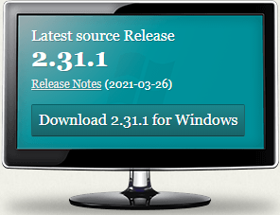
3. After clicking the download link, you will be redirected to the downloads page.
4. You should see a pop-up appear asking you where you like to download the file.

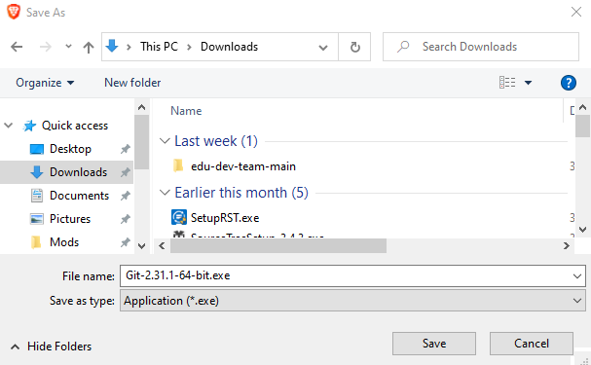

1. If you don’t see the pop-up, your browser may have already downloaded the file automatically. This system is setup to ask where I’d like to save files when they are downloaded.  
   - Look in your Downloads directory.
2. If you don’t see the file in the downloads directory and you know that the file did not download then click the text on the Downloads page that says: **Click here to download manually**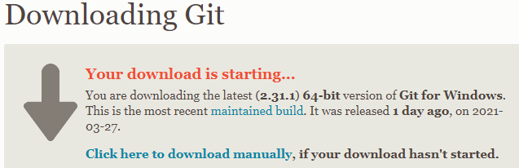
3. Once the file is downloaded, locate it and double-click the file to begin the installation process.

Mac (Downloading and Installing Git)

Linux (Downloading and Installing Git)

git init (command line)

Save Changes

View History

GUI (Graphical User Interface)

What is SourceTree

Downloading SourceTree

Installing SourceTree

SourceTree – git init

SourceTree - Save Changes

SourceTree - View Changes

SourceTree - View Previous Saves

What is GitHub

SourceTree - Uploading files to GitHub

Version Control with Microsoft Office

Version Control with Google Docs